**IOT Based Parking System**

### A Project Report

***Submitted by:***

**Jyoti 21BCS3883**

**Gauri Gupta 21BCS5654**

**Anish Gupta 21BCS4691**

**Puneet Kumar 21BCS3945**

**Priyanshu Gupta 21BCS3979**

***in partial fulfillment for the award of the degree of***

BACHELOR OF ENGINEERING

**IN**

### Computer Science and Engineering



**Chandigarh University**

November, 2024



# BONAFIDE CERTIFICATE

Certified that this project report **“IoT Based Smart Parking System using Raspberry Pi”** is the bonafide work of “**Jyoti ( 21BCS3883) ,Gauri Gupta (21BCS5654) , Anish Gupta ( 21BCS4691) ,Puneet Kumar (21BCS3945) ,Priyanshu Gupta (21BCS3979)”** who carried out the project work under my/our supervision.

**SIGNATURE**

### HEAD OF DEPARTMENT

B.E.-CSE

**SIGNATURE**

**SUPERVISOR**

B.E. - CSE

Submitted for the project viva-voce examination held on .

**INTERNAL EXAMINER EXTERNAL EXAMINER**

# TABLE OF CONTENTS

List of Figures 7

List of Tables 8

CHAPTER 1. INTRODUCTION 11

* 1. Identification of Client/ Need/ Relevant Contemporary issue 11
  2. Identification of Problem 11
  3. Identification of Tasks 11
  4. Timeline 11
  5. Organization of the Report 11

CHAPTER 2. LITERATURE REVIEW/BACKGROUND STUDY 12

Timeline of the reported problem 12

* 1. Existing solutions 12
  2. Bibliometric analysis 12
  3. Review Summary 12
  4. Problem Definition 12
  5. Goals/Objectives 12

CHAPTER 3. DESIGN FLOW/PROCESS 13

* 1. Evaluation & Selection of Specifications/Features 13
  2. Design Constraints 13
  3. Analysis of Features and finalization subject to constraints 13
  4. Design Flow 13
  5. Design selection 13
  6. Implementation plan/methodology 13

CHAPTER 4. RESULTS ANALYSIS AND VALIDATION 14

4.1. Implementation of solution 14

CHAPTER 5. CONCLUSION AND FUTURE WORK 15

* 1. Conclusion 15
  2. Future work 15

REFERENCES 16

APPENDIX 17

1. Plagiarism Report 17
2. Design Checklist 17

USER MANUAL 18

**ABSTRACT**

The Internet of Things (IoT) based parking system is an innovative solution designed to address the growing problem of parking space management in urban environments. With the rapid increase in the number of vehicles and limited parking spaces, finding an available parking spot has become a significant challenge for drivers, leading to congestion, wasted time, and increased fuel consumption. This IoT-based parking system utilizes a network of sensors, real-time data communication, and cloud-based platforms to provide a seamless and efficient parking experience. The system integrates various components such as ground sensors to detect occupied or vacant parking spots, mobile applications for users to view available spaces, and a central server that manages data and offers real-time updates. The sensors communicate the status of each parking space to the server, which then relays the information to drivers through a user-friendly app. The system also supports features such as reservation of parking spots, dynamic pricing, and automated payment solutions. By leveraging IoT technology, the proposed system optimizes the use of parking resources, reduces traffic congestion, and enhances the overall urban mobility experience. Furthermore, it provides valuable insights into parking patterns, enabling better urban planning and decision-making for municipalities. This report explores the design, implementation, and potential benefits of the IoT-based parking system, highlighting its contribution to smart cities and sustainable urban development.

# List of Figures

|  |  |
| --- | --- |
| **S. No** | **Description** |
| **3.1** | **Context Level Diagram** |
| **3.2** | **First Level DFD** |
| **3.3** | **Second Level DFD** |
| **3.4** | **Third Level DFD** |
| **3.5** | **Flowchart for the project** |
| **3.6** | **Block Diagram** |

# Chapter 1 INTRODUCTION

### 1.1 Project Definition/ Identification of client

The parking system has been under development for a while, and as of now, the majority of shopping malls feature a parking space status display using an Ultrasonic system to detect cars and a light to signal their presence. Smartness alone is insufficient for a smart parking system; everything must be made autonomous, including the automatic detection of money and the availability of slots.

Storage capacity: IoT calls for the gathering, accessing, processing, displaying, and sharing of massive volumes of data. The best and most cost-effective way to handle the data produced by IoT is to use the cloud, which offers infinite, affordable, and on-demand storage space.

* Processing speed: The IoT devices now in use have a low processing speed. IoT's compute requirements can be met by utilizing the Cloud's limitless processing power and on-demand paradigm.
* Communicative tools: The ability to connect, track, and manage devices from anywhere using the internet is made possible by cloud computing. IoT systems could monitor and operate objects in real-time from remote locations by utilizing built-in apps.
* Scalability: It permits dynamic resource augmentation or diminution. The system could have any number of "things" added to it or removed from it if cloud integration was offered. The cloud distributes resources based on the needs of items and applications.
* Availability: With cloud integration, locating resources at any time and from any location becomes very simple. With the cloud, apps are always up and running, and users receive ongoing services.

### Needs:-

* Increasing Traffic Congestion: As urban populations grow and the number of vehicles on the road increases, finding a parking spot has become more difficult, leading to traffic congestion. IoT-based systems can help alleviate this problem by providing real-time parking information, reducing the time spent searching for a spot.
* Limited Parking Spaces: Traditional parking systems are often limited in terms of capacity and efficiency. IoT-enabled systems can optimize the use of available parking spots, ensuring that parking resources are better utilized.
* Time and Fuel Wastage: Drivers often spend significant time and fuel searching for available parking. IoT-based smart parking systems provide real-time data on available spaces, thus reducing the amount of time spent driving in search of parking and lowering fuel consumption and emissions.
* Environmental Impact: By reducing the time vehicles spend circling parking lots and streets, IoT-based systems contribute to lowering carbon emissions, making urban environments cleaner and more sustainable.
* Improved Parking Management: IoT sensors and data analytics can help cities and parking lot operators manage parking more effectively, by identifying patterns and optimizing space usage. This allows for better planning of new parking facilities.
* Enhanced User Convenience: With mobile apps integrated into IoT systems, drivers can easily locate and reserve parking spots, making the parking experience more user-friendly and efficient. Features like automated payments further enhance convenience.
* Revenue Generation: Smart parking systems can implement dynamic pricing based on demand, helping municipalities and private operators generate more revenue from parking services, while also improving fairness in pricing.
* Reduced Stress for Drivers: IoT-based parking systems eliminate the frustration and stress of searching for parking spots, improving the overall driving experience in busy areas.
* Support for Smart City Initiatives: IoT-based parking is a key component of smart cities, contributing to the broader goal of digital transformation. It integrates with other smart city infrastructure, such as traffic management and environmental monitoring, to create a more connected and efficient urban environment.
* Data Collection and Analysis: IoT systems provide valuable data on parking trends, vehicle behavior, and space utilization, which can be used for urban planning, forecasting parking needs, and optimizing city infrastructure.
* Security and Safety: IoT-based systems can offer enhanced security features like real-time surveillance, alerts for unauthorized vehicles, and notifications of potential security issues in parking areas.
* Cost Efficiency: Over time, IoT-based parking solutions can reduce the operational costs of traditional parking systems by automating processes such as space monitoring, payment collection, and reporting.
* To understand major academic disciplines contributing to e-

### USP (Unique Selling Point) of the Project

* Real-Time Parking Availability: The system provides real-time data on available parking spots, allowing drivers to instantly find open spaces, reducing the time spent searching and minimizing traffic congestion.
* Seamless User Experience: Through an intuitive mobile app, users can easily locate, reserve, and even pay for parking spots in advance, offering a smooth, stress-free parking experience.
* Dynamic Pricing: The system supports flexible pricing models based on demand, time, and location, optimizing revenue generation for parking lot operators while offering users fair pricing.
* Data-Driven Insights: Advanced analytics and data collection capabilities help municipalities and businesses optimize parking resources, identify trends, and make informed decisions for better urban planning.
* Environmental Impact Reduction: By minimizing the time vehicles spend circling parking lots and reducing traffic congestion, the system helps lower fuel consumption and carbon emissions, contributing to cleaner urban environments.
* Smart Integration with Other Urban Systems: The system integrates seamlessly with existing smart city infrastructure, such as traffic management and public transportation, enhancing overall urban mobility and operational efficiency.
* Enhanced Security: Integrated IoT sensors and surveillance offer increased safety in parking areas, with real-time alerts for potential security issues, helping ensure safer parking experiences for both drivers and vehicles.
* Cost-Effective Operations: Automating processes such as space monitoring, payment collection, and reporting reduces operational costs for parking operators and municipalities, making the system highly cost-efficient in the long run.
* Scalability and Flexibility: The system is highly scalable, making it suitable for both small private parking lots and large public parking networks, ensuring adaptability to various parking needs across different urban settings.

### Research Objectives

The study is concentrated on the achievement of the following objectives -

* To Design and Develop an IoT-Enabled Smart Parking System Investigate the architecture, components, and technologies required to build an IoT-based smart parking system, including sensors, communication protocols, mobile applications, and cloud platforms.
* To Optimize Parking Space Utilization Explore methods to efficiently manage and allocate parking spaces using IoT sensors, ensuring maximum utilization of available parking areas and reducing the occurrence of vacant spots.
* To Enhance User Experience Through Real-Time Parking Information Develop a system that provides real-time data on parking availability, guiding drivers to available spaces via a mobile app and minimizing the time spent searching for parking.
* To Implement Dynamic Pricing Models for Parking Investigate the feasibility and benefits of implementing dynamic pricing strategies that adjust parking fees based on demand, time of day, and location, optimizing revenue generation while ensuring fairness for users.
* To Evaluate the Impact of the IoT Smart Parking System on Traffic Congestion Analyze how the IoT-based system can reduce traffic congestion by streamlining the parking process and providing drivers with real-time parking availability data, leading to less time spent on the road.
* To Assess the Environmental Benefits of Smart Parking Systems Study the environmental impact of the system by measuring reductions in fuel consumption, carbon emissions, and air pollution due to decreased time spent searching for parking.
* To Investigate the Security and Safety Features of IoT-Based Parking Systems Research the effectiveness of integrated security features such as real-time surveillance, theft detection, and vehicle monitoring to ensure safety for both vehicles and drivers in parking areas.
* To Explore Data Collection and Analytics for Urban Planning Examine the data generated by the smart parking system (e.g., parking patterns, space utilization, peak hours) and its potential for providing insights to city planners for better decision-making and improved urban infrastructure.

### Advantages

* Provides drivers with real-time information about available parking spots, reducing the time spent searching for a space and alleviating traffic congestion in busy areas.
* IoT sensors monitor parking space occupancy, ensuring efficient use of available parking spaces and helping parking lot operators maximize space utilization.
* By guiding drivers directly to available parking spots, the system helps reduce the amount of time spent circling parking areas, which in turn reduces traffic congestion and improves overall traffic flow.
* By reducing the time spent searching for parking, fuel consumption is lowered, leading to a decrease in carbon emissions and a positive environmental impact.
* IoT-based parking systems collect valuable data on parking behavior, including peak hours, parking duration, and usage trends. This data can be used for urban planning and infrastructure development, helping cities make informed decisions about parking needs and resource allocation.
* Automation of parking space management, payment collection, and monitoring reduces operational costs for parking lot operators, leading to lower maintenance and staffing expenses. Over time, this makes the system more cost-effective compared to traditional parking management.

### Project Planning/ Identification of Problem

### To design, develop, and implement an IoT-based smart parking system that optimizes parking space utilization, reduces traffic congestion, enhances user experience, and integrates with urban smart city infrastructure.

### The project covers the design and deployment of IoT sensors, real-time data communication, a mobile application for users, cloud-based data management, and system integration for urban mobility.

* Not enough parking spaces in a densely populated area.
* Poor use of available parking spaces.
* Time and gas used to find open parking spaces.
* Traffic congestion centred around poorly executed parking structures.
* Business parking spaces are taken by commuter parking.
* Inconvenient parking spaces.
* Poor parking price models.
* Proper handling of handicapped spaces.
* Unused private parking spaces.

### Project Scope/ Identification of Tasks

* + 1. The basic task of a smart parking solution is to identify a vehicle’s presence or absence in a particular parking space with a high degree of accuracy, and to pass on this data into a system for visualization and analysis – to be available for parking asset managers and/or enforcement officers.
    2. Keeping in mind the objectives mentioned above, the next step is to take into consideration following important features:
* Accuracy of detecting a vehicle presence/absence
* Total cost of solution
* Privacy concerns
* Detailed requirements and system design documents.
* Prototype of the IoT-based smart parking system.
* Working mobile application with key features.
* Deployed smart parking solution in a real-world environment.
* End-user documentation, training manuals, and customer support setup.
* Periodic maintenance and optimization reports.

This section outlines the scope and tasks for the IoT-Based Smart Parking System project, which will provide an innovative solution to modern urban parking problems. By breaking down the project into manageable tasks and phases, the project can be executed effectively while meeting key objectives such as optimizing parking space usage, improving user convenience, and enhancing urban mobility.

* IoT-based parking systems collect valuable data on parking behavior, including peak hours, parking duration, and usage trends. This data can be used for urban planning and infrastructure development, helping cities make informed decisions about parking needs and resource allocation.

The laser scanner sensors are well known for their accuracy of detecting a vehicle presence – therefore the sensor located at the entrance and exit of a parking area will count with high accuracy the entrance and exit of the vehicles, taking into consideration even two cars stopping very close to each other.

The total cost of solution considering the initial purchasing and installation cost, you will have low maintenance cost and no need of replacing batteries.

The sensors will just count the vehicles without recording any data. The system is not based on cameras, but again on sensors and eventually a display for counting the cars. Therefore, the privacy is totally granted.

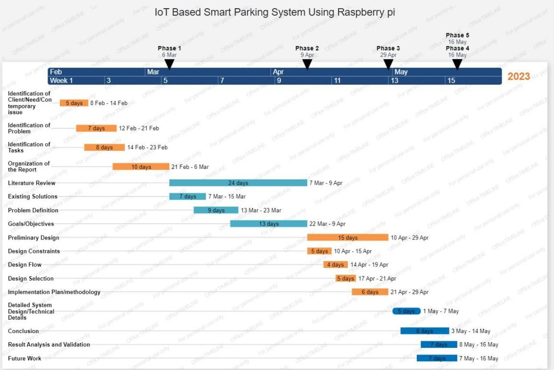

### Timeline

In this phase 1, focus is more on learning the tasks that is divided. In this timeline, learning phase will go and start its implementation.

In the next phase i.e. phase 2, development of the project model and building of its framework will start.

In the next phase i.e. phase 3, integration of the code and add the database will be done, which means to develop our model as a fruitful product for both vendors and users.

In this, overview of the project will be given, and all the features are going to be added to the website.

Apart from this, Objectives that the model will fulfill, will also be discussed.

### Chapter 3:

In this, design work will be done and the plan taken for the implementation of the building of our model will be executed.

Along with this, a deeper idea about the features will also be given that will going to be added to our model.

### Chapter 4:

In this, the final implementation of our final product will be given, i.e., .

### Chapter 5:

In this, discussion about the future aspect of our model will be given, i.e. what changes that are going to be inculcated in our model later on, and what are features are going to be added in it later on.

# Chapter 2

**LITERATURE REVIEW/BACKGROUND STUDY**

### Timeline of the reported problem

Several researchers have studied IoT-based parking systems and their effectiveness in improving parking management. For instance, in their study, Zhang et al. (2017) proposed an IoT-based parking system that uses wireless sensor networks to detect parking spaces' occupancy status. The system also provides real-time parking information to drivers, reducing the time spent searching for parking spots. The study showed that the proposed system significantly improved parking efficiency and reduced traffic congestion.

Similarly, Wu et al. (2018) proposed an IoT-based parking system that integrates various technologies such as cloud computing and big data analytics. The system uses sensors to detect parking spaces' occupancy status and provides real-time information to drivers through mobile applications. The study showed that the proposed system improved parking efficiency by reducing the time spent searching for parking spots and minimizing the number of vehicles on the road.

Moreover, in their study, Chen et al. (2019) proposed an IoT-based parking system that uses blockchain technology to ensure secure data exchange between parking operators and drivers. The system uses sensors to detect parking spaces' occupancy status and provides real-time parking information to drivers. The study showed that the proposed system improved parking efficiency, reduced traffic congestion, and provided secure and transparent data exchange.

### Existing solutions

Existing solutions for IoT-based smart parking systems integrate various technologies to optimize parking management in urban areas. Typically, these systems use sensors, cameras, and IoT devices to monitor parking spaces, identify vehicle occupancy, and relay real-time data to a centralized platform. Parking sensors, often embedded in the ground or attached to structures, detect the presence or absence of vehicles and transmit this information via wireless networks to cloud servers. Many systems use mobile applications to inform drivers of available parking spots, often with guidance features to assist navigation to these spaces. Some smart parking solutions include automatic payment and reservation options, reducing the hassle of finding and paying for parking manually.

Furthermore, advanced smart parking systems often incorporate machine learning algorithms and artificial intelligence to predict parking patterns, improving the efficiency of the system over time. For example, AI-based models analyze historical data to forecast peak hours and high-demand areas, allowing better traffic flow management and resource allocation. Additionally, some systems use computer vision and license plate recognition technologies for seamless entry and exit, especially in gated or restricted-access facilities. Integration with smart city platforms allows municipal authorities to monitor parking availability, manage traffic congestion, and enforce regulations more effectively. Overall, IoT-based smart parking solutions contribute significantly to reducing traffic congestion, lowering emissions, and enhancing urban mobility, benefiting both drivers and city management.

### Bibliometric analysis

A bibliometric analysis of research on IoT-based smart parking systems reveals the growing scholarly interest in this field, reflecting the pressing need to address urban parking challenges. The analysis includes metrics like publication count, citation trends, geographic distribution of research, and the influence of key authors, journals, and institutions. Studies have shown a steady increase in publications related to IoT-enabled smart parking since the concept’s introduction, with a notable surge in recent years due to advancements in sensor technology, cloud computing, and AI.

The majority of influential research originates from technologically advanced countries, including the United States, China, and European nations, where smart city initiatives have gained substantial support. Keyword analysis highlights frequent terms like "IoT," "smart city," "sensors," "vehicle detection," and "machine learning," underscoring the interdisciplinary nature of this field. Collaboration networks reveal a strong partnership among universities, research institutes, and industry stakeholders, fostering innovation in system design, data analytics, and user experience optimization. Furthermore, citation analysis points to seminal works on IoT architecture, data management, and urban mobility solutions, which continue to serve as foundational references for ongoing studies in smart parking systems. This bibliometric approach provides valuable insights into research trends, emerging technologies, and the potential future directions of IoT-based smart parking solutions.

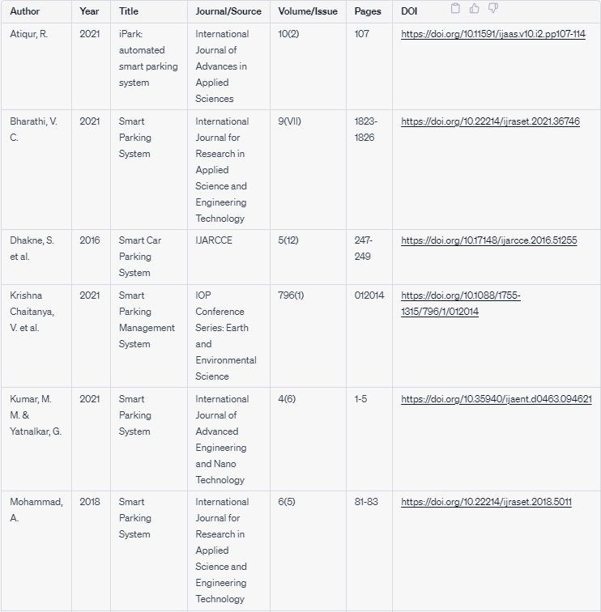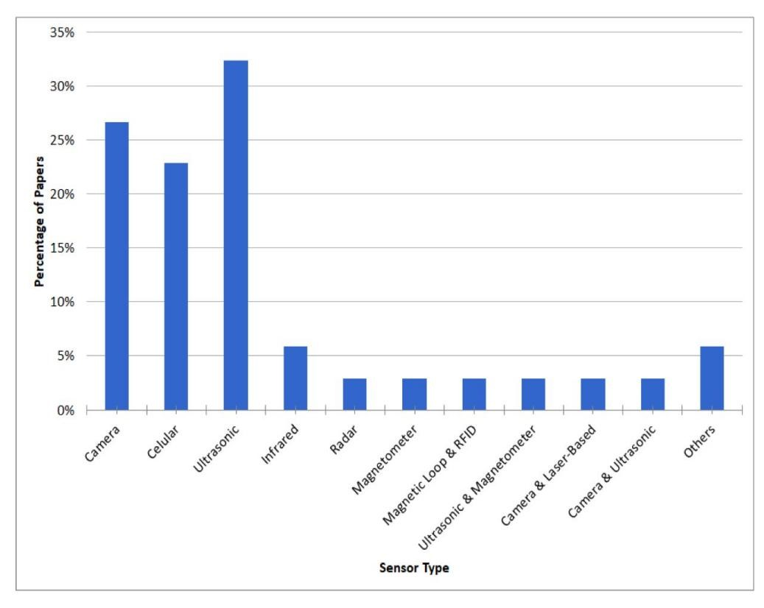

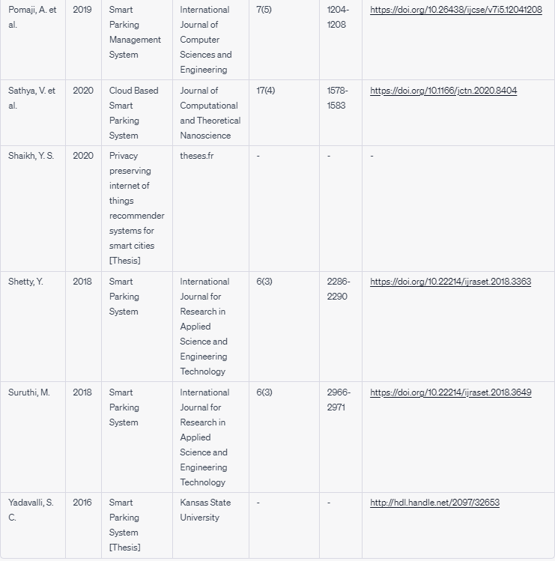

### Review Summary

A review of IoT-based smart parking systems highlights the effectiveness of these solutions in improving urban parking management by leveraging advanced technologies. These systems use IoT-enabled sensors and communication networks to detect vehicle presence, share real-time parking data, and assist drivers in locating available spaces. Key studies indicate that such systems significantly reduce the time spent searching for parking, which in turn decreases traffic congestion and vehicle emissions. Researchers have examined various components, including sensor accuracy, network reliability, data processing, and user interface design, which are all critical to creating a smooth user experience and ensuring operational efficiency.

Additionally, reviews suggest that integrating artificial intelligence and machine learning enhances system adaptability, allowing predictive analytics for better resource planning during peak hours. Challenges remain in areas such as data privacy, system scalability, and cost-effectiveness, especially in large cities with high infrastructure demands. Solutions are being explored to address these issues, including blockchain for secure data management, 5G for faster data transmission, and solar-powered sensors for energy efficiency. Overall, the review underscores that IoT-based smart parking systems offer a promising approach to address the growing need for efficient parking management, contributing to smarter, more sustainable urban mobility.

The IoT Smart Parking System presents a significant advancement in the way parking is managed in modern urban environments. By improving the efficiency of parking operations, reducing congestion, and providing a better user experience, it helps address some of the most common issues associated with urban mobility. However, the system’s success depends on overcoming challenges like initial costs, data security concerns, and widespread user .

### Problem Definition

Parking spaces have grown to be a major issue in urban growth. In this situation, the number of automobiles are quickly overtaking the number of parking spaces that are available for both people and staff of any facility. The introduction of smart parking management system can help to address this problem by helping drivers match up with available parking spaces individually, saving time, improving parking space usage, lowering management costs, and reducing traffic congestion.

In order to find a suitable spot to park, people typically move around the parking areas. The automated car parking system was developed to address this issue. It is necessary to use assistive technology, which might give registered users of cell phones and their applications access to parking information. Users can access the service by registering, and in the event that a booking is made,

### What is to be done:

* Real-Time Space Detection: Implement IoT-enabled sensors (e.g., magnetic, ultrasonic, or camera-based sensors) at each parking spot to detect vehicle presence. These sensors will transmit real-time occupancy data to a centralized system.
* Data Collection and Analysis: Use a cloud-based platform to collect, process, and store data on parking availability. Implement machine learning algorithms to analyze historical and real-time data to predict parking availability trends and high-demand periods, helping manage parking resources better.
* User Interface and Notifications: Develop a mobile or web application for drivers that shows the availability of parking spaces in real time. Include features such as navigation to the available spots, parking reservation options, and payment processing for a seamless experience.
* Automated Payment and Access Control: Integrate automated payment systems (e.g., through mobile apps or QR codes) and access control mechanisms (e.g., RFID, license plate recognition) to streamline entry and exit, reducing manual intervention.
* Energy Efficiency and Sustainability: Use low-power IoT devices and, where feasible, integrate renewable energy sources like solar panels to reduce the energy consumption of the sensors and extend the system’s lifespan.
* Scalability and Security: Design the system to be easily scalable to accommodate future growth in parking demands and ensure data security, particularly for sensitive user information and payment details. Techniques like encryption and blockchain could be explored for secure data transmission.
* Integration with Smart City Infrastructure: Coordinate with other smart city systems (e.g., traffic management and public transportation) to provide comprehensive urban mobility solutions, aiding city authorities in managing traffic flow and reducing congestion.

### How it is to be done:

* + Requirement Analysis and Planning: Begin by identifying the specific parking challenges in the target area, such as parking demand patterns, traffic congestion, and available infrastructure.
  + Engage stakeholders, including city authorities, local businesses, and technology providers, to determine requirements and set goals.
  + Develop a project plan that outlines system objectives, budget, timeline, and expected outcomes.
  + Technology Selection: Choose appropriate sensors (e.g., magnetic, ultrasonic, infrared) that suit the environmental conditions and specific requirements (indoor/outdoor use, accuracy, power source).
  + Select an IoT communication protocol such as LoRaWAN, Zigbee, or cellular networks (e.g., 4G/5G) based on factors like distance, data transmission rate, and network coverage. Decide on a cloud provider or local server setup for data storage and processing, ensuring it meets scalability and data security requirements.
  + Sensor and Device Installation: Install IoT sensors in each parking space to detect vehicle presence and occupancy status. Test sensor positioning and calibration to ensure accurate detection. Set up gateway devices to aggregate sensor data and transmit it to the cloud or central server, selecting locations that maximize coverage while minimizing interference.
  + Data Processing and Cloud Integration: Develop cloud-based software for data collection and management. This includes data processing algorithms to analyze sensor data, detect parking availability in real-time, and manage system updates. Implement machine learning models to analyze historical data for predicting future parking availability, optimizing the allocation of parking spaces during peak hours.
  + Application Development: Create a user-friendly mobile or web application for drivers. Features should include real-time parking space availability, navigation to available spots, parking reservation options, and payment integration. For administrators, develop a dashboard to monitor parking occupancy, detect faulty sensors, view historical data, and manage system settings.
  + Integration of Payment and Access Control Systems: Implement automated payment systems that allow users to pay via the app, using various options like digital wallets or credit cards. Integrate access control mechanisms, such as RFID readers or license plate recognition cameras, to enable autmated entry and exit for drivers with parking reservations or subscriptions.
  + Testing and Calibration: Conduct thorough testing of each component, including sensors, network connectivity, data transmission, and application functionalities. Adjust sensors and fine-tune the data processing algorithms for accuracy. Perform field tests to simulate real-world conditions, checking the performance of the entire system in peak and off-peak hours.

### What not to be done:

* + - Do not compromise on website security, as this can harm the reputation of the website and reduce user trust.
    - Do not overload the website with unnecessary features that can slow it down and create a poor user experience.
    - Do not ignore user feedback, as this can lead to missed opportunities for improvement.
    - Do not neglect mobile optimization, as this can result in a poor user experience for mobile users, who make up a significant portion of e- commerce customers.

### Goals/Objectives

The goal of an IoT-based parking system is to optimize the management and utilization of parking spaces through the use of connected devices and technologies. The main objectives of an IoT-based parking system may include:

1. Efficient Space Utilization: IoT-based parking systems aim to utilize parking spaces effectively and optimize their occupancy rates. This can be achieved by monitoring parking spaces in real-time using sensors and providing real-time information to drivers about the availability of parking spaces. This helps in reducing the time spent searching for parking spaces and minimizing congestion in parking areas.
2. Improved User Experience: IoT-based parking systems aim to enhance the overall user experience for drivers and parking lot operators. This can be achieved by providing seamless and convenient parking experiences through mobile apps or other connected devices, allowing users to easily locate, reserve, and pay for parking spaces. It can also include features such as automated entry and exit gates, cashless payment options, and
3. Enhanced Safety and Security: IoT-based parking systems aim to improve safety and security in parking areas. This can be achieved through the use of connected surveillance cameras, sensors, and other devices that can detect and alert on issues such as unauthorized access, overcrowding, or security breaches. Real-time monitoring and alerts can help prevent thefts, vandalism, and other security incidents in parking areas.
4. Sustainable Parking Solutions: IoT-based parking systems can contribute to sustainability goals by optimizing parking space usage, reducing congestion, and minimizing the environmental impact of parking. For example, by
5. providing real-time information on parking availability, drivers can avoid unnecessary circling and reduce fuel emissions. IoT-based parking systems can also incorporate features such as electric vehicle (EV) charging stations and promote the use of shared parking spaces, contributing to a greener and more sustainable parking ecosystem.
6. Data-Driven Parking Management: IoT-based parking systems can provide valuable data and insights for parking lot operators to improve their operations and decision-making. Data such as parking occupancy rates, usage patterns, and payment trends can be collected and analyzed to optimize pricing, staffing, and maintenance strategies. This can result in better resource allocation, cost savings, and improved overall efficiency of parking operations.
7. Scalability and Flexibility: IoT-based parking systems are designed to be scalable and adaptable to different types of parking facilities, such as on-street parking, off-street parking, and multi-level parking garages. They can also be integrated with existing parking management systems and other smart city infrastructure, allowing for interoperability and flexibility in implementation.

Overall, the goals and objectives of an IoT-based parking system are to optimize parking space utilization, enhance user experience, improve safety and security, promote sustainability, enable data-driven parking management, and provide scalability and flexibility in implementation.

# Chapter 3 DESIGN FLOW/PROCESS

# Evaluation & Selection of Specifications/Features

The evaluation and selection of specifications for an IoT-based smart parking system focus on optimizing performance, reliability, user experience, and cost-effectiveness. Key features are chosen based on their ability to meet system objectives such as accurate space detection, real-time data transmission, and seamless user interaction. Sensor selection is crucial, with options like ultrasonic, infrared, or magnetic sensors evaluated for accuracy, durability, and suitability for outdoor or indoor environments. Wireless communication protocols are selected based on criteria like range, bandwidth, and energy consumption, with protocols like LoRaWAN and NB-IoT commonly preferred for long-range, low-power needs.

Data processing capabilities are assessed to ensure efficient handling of large volumes of data from multiple sensors, and cloud-based platforms are selected for scalability and reliability. User interface specifications are chosen to enhance the user experience through real-time updates on parking availability, navigation assistance, and payment options, ensuring that the app is intuitive and responsive. For security, features such as encryption and secure payment integration are prioritized to protect user data and transactions.

Additionally, sustainability is a key consideration, with options like solar-powered sensors evaluated to reduce operational costs and environmental impact. These specifications are selected based on testing, user needs, and environmental factors, ensuring that the smart parking system is reliable, secure, and scalable while maintaining ease of use and efficiency for drivers and administrators alike.

To evaluate and select the specifications/features for an IoT-based parking system using Arduino, we can consider the following features:

1. Slot availability display: The system should display the number of available parking slots in real-time, enabling users to easily find a vacant slot.
2. Automatic payment system: The system should have an automatic payment system that enables users to pay for their parking without the need for cash or cards. This could be achieved using mobile payments, such as Apple Pay or Google Wallet.
3. Real-time monitoring: The system should provide real-time monitoring of parking slots, allowing the parking operator to identify any issues or problems quickly.
4. User-friendly interface: The system should have a user-friendly interface that is easy to use for both operators and users.

The selection of specifications for an IoT-based smart parking system also involves detailed evaluation of system architecture, data accuracy, network latency, and maintenance needs. The system architecture is designed to be modular, allowing for scalability and easy expansion to accommodate future growth in parking demands or the integration of additional features. Data accuracy is a top priority, as precise detection of vehicle presence directly impacts the reliability of the system. For this, high-resolution sensors are favored, and algorithms are developed to filter out potential errors such as false detections caused by environmental factors.

Network latency is another crucial specification. Low-latency communication is essential for providing real-time updates to users and minimizing delays in occupancy data transmission. Protocols like 5G and Wi-Fi are evaluated for higher-density environments where rapid data flow is required, while protocols like LoRaWAN are preferred in low-bandwidth settings for their energy efficiency. Power management also influences specification choices; for instance, energy-efficient sensors and solar charging options are considered to ensure that the system operates sustainably with minimal downtime, even in remote or power-limited areas.

Maintenance and durability are assessed as well, as components must withstand varying environmental conditions, especially for outdoor deployments. Therefore, ruggedized sensors with weatherproof casings are prioritized in regions prone to harsh climates. To enhance system longevity, automated diagnostics and fault-detection algorithms are integrated into the backend, alerting administrators to sensor malfunctions or data anomalies for quick troubleshooting.

Data processing capabilities are assessed to ensure efficient handling of large volumes of data from multiple sensors, and cloud-based platforms are selected for scalability and reliability. User interface specifications are chosen to enhance the user experience through real-time updates on parking availability, navigation assistance, and payment options, ensuring that the app is intuitive and responsive. For security, features such as encryption and secure payment integration are prioritized to protect user data and transactions.

# Design Constraints

The design of the IoT-based parking system must consider various constraints, including:

The design of an IoT-based smart parking system is shaped by several constraints that impact the choice of technology, infrastructure, and functionality. Budget limitations are a primary constraint, as the cost of IoT sensors, network infrastructure, cloud services, and ongoing maintenance must be managed to ensure the system’s affordability, especially for large-scale urban deployments. This financial constraint often limits the choice of sensors to cost-effective yet reliable options, such as magnetic or ultrasonic sensors, rather than more expensive camera-based or advanced multi-sensor solutions.

Environmental conditions also pose significant design challenges, particularly in outdoor settings where sensors and devices must withstand varying weather, temperature extremes, and potential vandalism. As a result, devices need to be durable, weather-resistant, and ideally designed with ruggedized casings, adding complexity and potential cost to the system. Energy limitations influence design decisions as well, especially in areas where access to reliable power sources is difficult. Low-power IoT protocols like LoRaWAN or NB-IoT are often selected to address this, and renewable energy sources such as solar power are considered to support energy efficiency.

Data privacy and security constraints are critical, as personal data (e.g., vehicle information and payment details) must be protected. Compliance with local and international data protection regulations (such as GDPR) requires the implementation of encryption, secure authentication methods, and data anonymization techniques, which can increase development complexity. Network bandwidth and latency constraints are also crucial, particularly in busy urban areas where multiple sensors must transmit data simultaneously without delays. Designing for low-latency, reliable connectivity can restrict the selection of communication protocols, leading to higher infrastructure costs for high-bandwidth solutions like Wi-Fi or 5G.

Scalability presents another constraint; the system must be designed to handle an increasing number of users and connected devices without degrading performance. This requires a flexible architecture and robust cloud infrastructure, adding both technical and budgetary challenges. Compatibility with existing infrastructure is a final constraint, as the system may need to integrate with existing parking facilities, payment systems, and city management platforms. This requires careful planning to ensure interoperability, often involving customization and compliance with existing standards, which can increase the complexity of deployment and maintenance.

These design constraints necessitate a careful balance between functionality, cost, durability, and scalability, shaping an IoT-based smart parking system that is reliable, secure, and adaptable to diverse urban environments while remaining feasible within budget and technical limitations.

**Security**: The website should have strong security measures in place to protect users' personal and financial information. This may include SSL encryption, secure password requirements, and two-factor authentication. Security is essential for building trust with your customers and protecting your business

from potential breaches.

**Scalability**: The website should be designed to accommodate growth and expansion, such as adding new products, features, and functionalities. Designing with scalability in mind can help you avoid costly redesigns in the future.

**Compliance**: Your e-commerce website should comply with relevant laws and regulations. This includes the General Data Protection Regulation (GDPR).

# Analysis of Features and finalization subject to constraints

In designing an IoT-based smart parking system, the analysis and finalization of features must carefully account for both the desired functionality and the constraints identified. Each feature is assessed for feasibility within the project’s budget, energy, environmental, and regulatory limitations. Real-time parking occupancy detection is prioritized, as it is essential for the core functionality of the system. This feature relies on cost-effective yet accurate sensors like ultrasonic or magnetic options, chosen for their balance of affordability, accuracy, and reliability under various environmental conditions. More advanced sensors, such as camera-based systems, may be considered for high-priority zones if the budget allows.

Low-latency communication and reliable data transmission are critical to ensure real-time updates for users; thus, energy-efficient communication protocols like LoRaWAN or NB-IoT are selected for extended battery life and low operating costs. Where high bandwidth is necessary (e.g., for image or video data in gated parking), options like Wi-Fi or 5G are implemented selectively, balancing performance and cost. To address energy limitations, the design incorporates renewable options like solar panels to power sensors, especially in remote or outdoor settings where direct power access may be challenging.

User experience features, such as real-time availability updates, parking navigation, and payment integration, are essential for the system’s effectiveness and user adoption. A streamlined mobile app with secure payment options and real-time alerts is prioritized, ensuring compliance with data privacy regulations through encrypted data storage and secure authentication protocols. Automated payment processing and reservations are considered high-value additions, with final decisions guided by budget and user demand.

Data security and privacy are further integrated into feature design, meeting regulatory requirements like GDPR. Data encryption, anonymization, and secure cloud storage are mandatory components, particularly for protecting personal and payment information, adding necessary security layers without compromising on usability or real-time functionality.

Scalability is built into the system through a modular architecture and cloud-based storage, enabling the addition of more parking spaces, users, or sensors without major infrastructure changes. Compatibility with existing urban infrastructure also influences feature finalization, focusing on interoperability with current parking management systems, traffic control systems, and smart city platforms, ensuring ease of deployment and long-term adaptability.

In summary, the finalized features for the IoT-based smart parking system offer a balanced approach that meets essential user needs and system requirements within the identified constraints. By carefully evaluating each feature’s practicality, affordability, and compatibility, the system achieves a reliable, secure, and scalable solution that enhances urban mobility and addresses parking challenges efficiently.

Data processing capabilities are assessed to ensure efficient handling of large volumes of data from multiple sensors, and cloud-based platforms are selected for scalability and reliability. User interface specifications are chosen to enhance the user experience through real-time updates on parking availability, navigation assistance, and payment options, ensuring that the app is intuitive and responsive. For security, features such as encryption and secure payment integration are prioritized to protect user data and transactions.

# Design Flow

Design flow also known as the design process basically refers to the series of steps that a we follow to create a product or solution. The design flow typically includes several stages, such as conceptualization, research, prototyping, testing, and implementation. These stages can be iterative, with the designer returning to previous stages as necessary to refine and improve the design. The two design flows for the designing of the project are as follows-

The design flow for an IoT-based smart parking system involves a step-by-step approach from initial planning to system deployment and testing, ensuring that each component is effectively integrated and performs optimally in real-world conditions. Here’s an outline of the design flow:

Requirement Analysis and Feasibility Study:

Begin with a comprehensive analysis of user requirements, environmental conditions, and technical constraints. Engage stakeholders, including city officials, engineers, and potential users, to determine the necessary features, such as real-time space detection, payment integration, and data privacy.

Conduct a feasibility study to evaluate the budget, available technology, and system scalability, defining the scope and limitations of the project.

System Architecture Design:

Develop a high-level architecture that outlines the major system components: sensors for occupancy detection, gateways for data aggregation, a cloud server for data processing and storage, and a mobile application for user interaction.

Decide on the communication protocols (e.g., LoRaWAN, NB-IoT, Wi-Fi) and establish the data flow between sensors, gateways, and the cloud. Ensure that the architecture is modular to support scalability and future expansion.

Component Selection:

Choose suitable sensors based on factors like accuracy, durability, and cost. Ultrasonic or magnetic sensors are commonly selected for their balance of reliability and affordability.

Select gateways, cloud services, and communication networks that meet the requirements for data transmission range, latency, and power consumption. Ensure compatibility among components to avoid integration issues.

Detailed System Design:

Define the specifics of each module, including sensor placement, power sources (e.g., solar panels for remote areas), and network coverage. Design the backend system to handle data processing, including real-time updates, historical data analysis, and predictive algorithms for parking space availability.

Outline security measures, such as encryption, authentication, and compliance with data privacy regulations.

Software Development:

Develop the software for both the user-facing mobile application and the backend system. The app should provide real-time updates on parking availability, navigation, reservations, and payment options.

Build an administrator dashboard for system monitoring, diagnostics, and data analytics. Use APIs to enable integration with other smart city services and data-sharing platforms.

System Integration and Initial Testing:

Integrate all components and verify that sensors, gateways, cloud services, and the application work together seamlessly. Conduct preliminary testing in a controlled environment to assess data transmission reliability, system latency, and response time.

Validate sensor accuracy, mobile app functionality, and user experience, identifying and resolving any software bugs or hardware issues.

Field Testing and Calibration:

Deploy the system in a pilot area to observe real-world performance. Calibrate sensors to ensure accurate detection, particularly in outdoor conditions where environmental factors may affect readings.

Perform load testing to assess the system’s performance under peak usage, identifying any weaknesses in data transmission, latency, or server capacity.

Feedback Collection and Refinement:

Gather feedback from pilot users and system administrators to evaluate usability, functionality, and system reliability. Address any limitations, adjusting sensor placements, recalibrating software algorithms, or optimizing network coverage as needed.

Final Deployment and Monitoring:

Roll out the system across the full deployment area, conducting final checks to ensure all components are operational and integrated. Establish a regular maintenance schedule for sensor calibration, software updates, and troubleshooting.

Implement continuous monitoring through the administrator dashboard to track system performance, monitor occupancy patterns, and detect faults or outages in real time.

Documentation and Future Scalability Planning:

Document the system design, installation processes, and maintenance requirements to aid future expansions or upgrades.

Plan for scalability by documenting potential areas for expansion, software improvements, or technology upgrades, ensuring that the system can adapt to growing urban demands and advances in IoT technology.

This design flow ensures a structured approach to developing a robust, reliable, and user-friendly IoT-based smart parking system that can be scaled and maintained effectively over time.

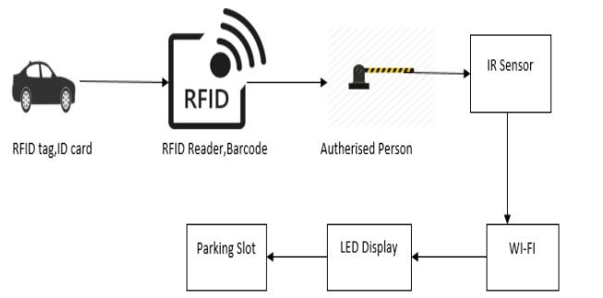

Conduct a feasibility study to evaluate the budget, available technology, and system scalability, defining the scope and limitations of the project. Perform load testing to assess the system’s performance under peak usage.

Design selection

The design selection for an IoT-based smart parking system is a critical phase, balancing functionality, cost, scalability, and environmental compatibility. Key design decisions are made based on a thorough evaluation of available technologies, the specific requirements of the urban environment, and the project constraints. Here is an outline of the primary design choices:

Sensor Technology Selection:

For vehicle detection, the selection is based on accuracy, durability, and cost-effectiveness. Ultrasonic or magnetic sensors are often chosen for their reliability in detecting vehicle presence and adaptability to different parking environments. Ultrasonic sensors work well in covered or underground parking, while magnetic sensors are suited for outdoor environments where they are less affected by weather conditions.

Advanced sensor options like camera-based systems or infrared sensors may be selectively deployed in high-traffic areas if budget and infrastructure support allow, as they offer greater accuracy but come at a higher cost.

Communication Protocol Selection:

Communication protocol selection is based on range, bandwidth, and energy efficiency. LoRaWAN and NB-IoT are often preferred for low-power, long-range communication, suitable for large parking areas where sensors are distributed widely. These protocols are also beneficial for their low energy consumption, enabling battery-powered sensors to operate for extended periods without frequent maintenance.

In smaller, high-density areas where low latency is essential, Wi-Fi or 5G may be used to support real-time data transmission and high bandwidth, especially if video-based sensors are employed.

Cloud and Data Processing Platform:

Cloud-based data processing is selected for scalability and centralized management of sensor data. A cloud platform allows for data storage, real-time processing, predictive analytics, and easy expansion as more sensors or users are added. This setup also supports remote monitoring and maintenance, essential for large-scale urban deployments.

To optimize performance, the cloud infrastructure is designed to handle high data throughput during peak hours, ensuring that real-time updates reach users without latency issues.

Mobile Application and User Interface:

A user-friendly mobile app is chosen as the primary interface for drivers, providing real-time parking availability, navigation to available spaces, and payment options. To ensure ease of use, the design emphasizes intuitive navigation, quick loading times, and streamlined payment integration.

The app also includes customizable features like alerts for parking reservations, parking duration reminders, and payment receipts to improve the user experience and promote consistent system usage.

Energy Efficiency and Power Management:

Solar-powered sensors are selected for outdoor installations, ensuring sustainable operation and reducing reliance on traditional power sources, which may be challenging to access in urban parking lots. In areas without sunlight access, low-power protocols and battery-efficient sensors are chosen to minimize maintenance costs.

The selection of energy-efficient hardware and communication protocols further extends battery life, allowing for reduced maintenance frequency and ensuring reliable, long-term operation.

Security and Data Privacy:

Data privacy is prioritized in the design, with encryption and secure cloud storage to protect user data. Compliance with regulations like GDPR or local data protection laws guides the selection of encryption methods and secure authentication processes.

Access control is another key security feature, with options like RFID readers or license plate recognition cameras considered to allow authorized access and prevent unauthorized entry in gated parking zones.

Scalability and Modularity:

The system is designed with a modular structure, enabling easy expansion by adding more sensors, gateways, or network infrastructure as needed. This modular approach allows the system to adapt to future growth in parking demand and supports the addition of new features, such as advanced analytics or smart city integrations, without major redesigns.

Scalability is further supported by the cloud-based infrastructure, which allows resources to be scaled up or down based on system demand.

Integration with Existing Infrastructure:

The design ensures compatibility with existing parking and payment systems to enable smooth integration into current urban environments. APIs are used to facilitate data exchange between the parking system and other smart city platforms, such as traffic management systems or public transportation networks, improving overall urban mobility.

In summary, the design selection for an IoT-based smart parking system is driven by a careful balance of functionality, user needs, sustainability, and budget constraints. Each component and feature is selected to create a cost-effective, user-friendly, and scalable solution that aligns with urban parking challenges, supporting improved efficiency, ease of use, and adaptability for future expansion.

allows developers to use their preferred front-end technology and enables them to have full control over the user interface, which can be designed to be unique. The headless architecture also offers more opportunities for customization, such as adding additional functionality to the website, like incorporating third-party applications or integrating additional services. However, the headless architecture requires more technical knowledge and resources to implement and maintain.

On the other hand, a PWA design is suitable for projects that prioritize speed, responsiveness, and mobile optimization. PWAs are designed to load quickly, even in low network conditions, and offer a seamless mobile experience, with features such as push notifications and offline functionality. PWAs can also help to improve user engagement, by increasing the amount of time users spend on the website, leading to more sales and revenue. However, a PWA design may not be as customizable as a headless architecture, and may not be suitable for projects that require advanced customization and flexibility.

In general, a headless e-commerce architecture is more suitable for larger and more complex e-commerce projects that require more customization and flexibility. On the other hand, a PWA design is more suitable for smaller and simpler e-commerce projects that prioritize speed, responsiveness, and mobile optimization.

However, it's important to note that the best design for an e-commerce project ultimately depends on the specific requirements and goals of the project. It's recommended to consult with a team of experienced developers and designers to determine the best design approach for the project.

## Implementation plan/methodology

To implement Design 1, we can follow the following steps:

1. LGather the required components, including Arduino boards, IR sensors, website displays, and WiFi modules.
2. Assemble the hardware components and connect them to the Arduino board following the wiring diagrams.
3. Write the code for the Arduino board to read the sensor data and display it on the LCD screen.
4. Develop a webserver that allows users to view parking availability and make payments using mobile payments.
5. Integrate the website with the Arduino board and WiFi module to enable real-time monitoring and automatic payment processing.
6. Test the system in a real-world environment to ensure it functions as expected.
7. Deploy the system in a parking lot, providing training to the parking operator and users on how to use the system effectively.

Throughout the implementation process, we must consider the design constraints to ensure the system complies with relevant standards and regulations. We should also continuously evaluate the system's performance and make adjustments as necessary to improve its functionality and efficiency.

**Launch:** Once the website has been developed, the content has been created, and the testing has been completed, the next step is to launch the website. This involves setting up payment gateways, shipping options, and configuring website settings, including tax rates and shipping rates. The website's performance under heavy load also needs to be tested to ensure that it can handle a high volume of traffic.

* + - Set up payment gateways
    - Set up shipping options
    - Configure website settings, including tax rates and shipping rates
    - Test website performance under heavy load

**Maintenance:** The final step in the implementation plan/methodology for an e- commerce website project is maintenance. This involves updating the software and platform, adding new products, implementing new features and functionality, and analyzing website analytics to improve the user experience. Regular maintenance is essential to ensure that the website continues to function correctly and meet the needs of the business.

* + - Update the software and platform
    - Add new products
    - Implement new features and functionality
    - Analyze website analytics and implement improvements to the user experience

## Data Flow Diagram:

* + - Data Flow Diagram show the flow of data from external entities into the system, and from one process to another symbols for drawing a DFD: Rectangles representing external entities, which are sources or destinations of data.
    - Ellipses representing processes, which take data as input, validate and process it and output it.
    - Arrows representing the data flows, which can either, be electronic data or physical items
    - Open-ended rectangles or a Disk symbol representing data stores,

including electronic stores such as databases or stacks of paper.

## First level DFD:

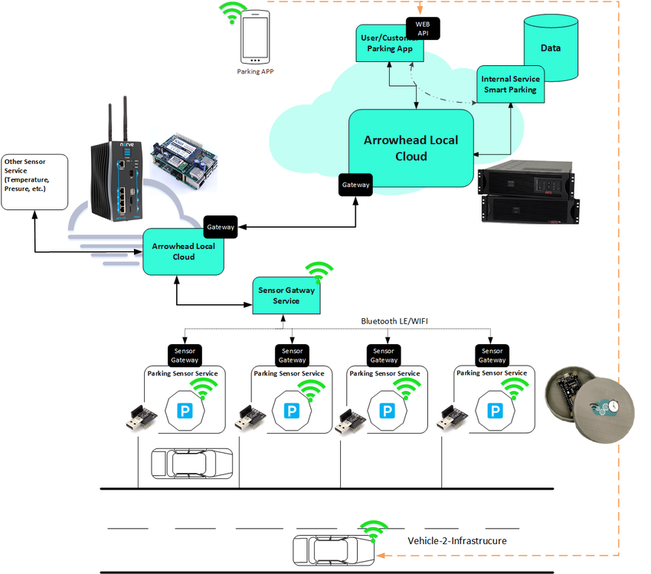

Fig [3.2] First Level DFD

However, it's important to note that the best design for an e-commerce project ultimately depends on the specific requirements and goals of the project. It's recommended to consult with a team of experienced developers and designers to determine the best design approach for the project.

## Second Level DFD:

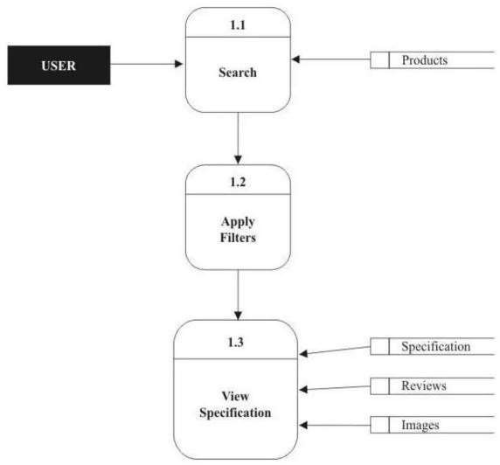

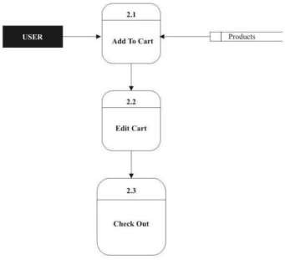Fig [3.3.1] Second Level DFD

Fig [3.3.2] Second Level DFD

## Third Level DFD:

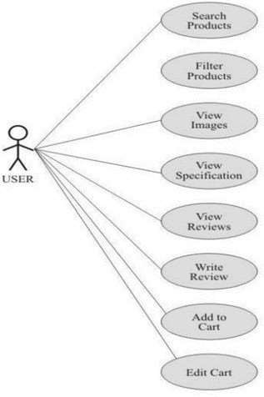

Fig [3.4] Third Level DFD

## Flowchart for the project:

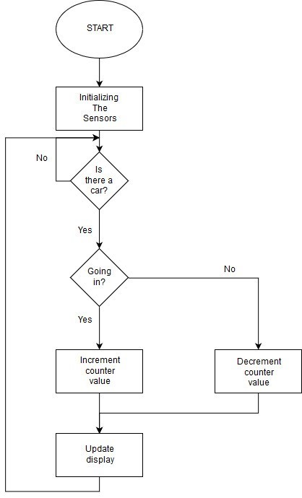

Fig [3.5] Flowchart for the project

## Block Diagram:

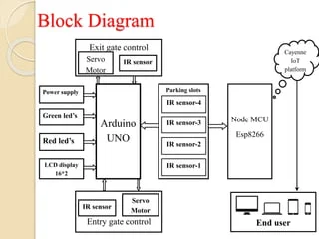

Fig [3.6] Block Diagram

The user interface enables users to browse and interact with the website. User registration and authentication manage user accounts and access to features. The product catalog showcases available products, while search and filtering help users find specific items. The shopping cart and checkout handle the purchasing process, and order management deals with order processing and tracking. Together, these components create a streamlined platform for local buyers and sellers to engage in online commerce.

# CHAPTER 4.

**RESULTS ANALYSIS AND VALIDATION**

### 4.1. Implementation of solution

The objective of our project is to develop a smart parking system that can provide real-time information about the availability of parking slots to the users. We have implemented this solution using ESP32 as the microprocessor, which communicates with the web server to update the status of each parking slot.

To detect the occupancy of a parking slot, we have used three types of sensors: RFID reader, RF sensor, and IR sensor. The RFID reader is used to detect the presence of a vehicle by reading the RFID tag attached to it. The RF sensor uses the principle of magnetic induction to detect the presence of a metal object, such as a car. The IR sensor detects the infrared radiation emitted by a vehicle and can be used to detect the presence of a car in a parking slot.

The ESP32 microprocessor is connected to each of these sensors and constantly monitors their status. Whenever a sensor detects the presence of a vehicle, it sends a signal to the microprocessor, which updates the slot status on the web server. Although for now we are using Ubidots for displaying the status of parking slots.

One of the key advantages of this system is that it allows users to easily find an available parking slot, reducing the time and effort required to find a parking spot. Moreover, the system can also provide real-time data about the utilization of parking spaces, allowing parking lot operators to optimize the allocation of parking spaces.

In conclusion, our implementation of an IoT-based smart parking system using ESP32 and various sensors has demonstrated the feasibility of using IoT technologies to improve the efficiency of parking management. The system can provide real-time information about the availability of parking slots, making it easier for users to find a parking spot and for parking lot operators to optimize their operations.

The implementation of our IoT-based smart parking system using ESP32 microprocessor, IR sensor, RF reader, and RF card can benefit from leveraging modern tools and technologies to achieve our objectives. Let's explore how we can accomplish each objective:

Stability.

A plan for scalability is established, documenting procedures for adding new sensors, expanding network coverage, and increasing cloud storage, ensuring that the system can scale with future demand.

This implementation approach creates a fully functional, user-centric IoT-based smart parking system that addresses urban parking challenges efficiently. With careful execution across each phase, the system achieves reliability, scalability, and ease of use, supporting real-time parking management and enhanced driver experience.

Following successful pilot testing, the system is deployed across the entire parking area. A maintenance schedule is set up for regular sensor checks, battery replacements, and software updates. Monitoring tools are activated on the admin dashboard, allowing for real-time tracking of system performance, automated error detection, and proactive maintenance alerts.

### Source Code:

**All the routes related to backend:**

const express = require("express"); const app = express();

const cookieParser = require("cookie-parser"); const bodyParser = require("body-parser"); const fileUpload = require("express-fileupload"); const path = require("path");

const errorMiddleware = require("./middleware/error");

// Config

if (process.env.NODE_ENV !== "PRODUCTION") { require("dotenv").config({ path: "backend/config/config.env" });

}

app.use(express.json()); app.use(cookieParser());

app.use(bodyParser.urlencoded({ extended: true })); app.use(fileUpload());

// Route Imports

const product = require("./routes/productRoute");

const user = require("./routes/userRoute"); const order = require("./routes/orderRoute");

const payment = require("./routes/paymentRoute"); app.use("/api/v1", product);

app.use("/api/v1", user); app.use("/api/v1", order); app.use("/api/v1", payment);

app.use(express.static(path.join( dirname, "../frontend/build"))); app.get("*", (req, res) => {

res.sendFile(path.resolve( dirname, "../frontend/build/index.html"));

});

// Middleware for Errors app.use(errorMiddleware); module.exports = app;

### Here is the code for order Route:

const express = require("express"); const {

newOrder, getSingleOrder, myOrders, getAllOrders, updateOrder, deleteOrder,

} = require("../controllers/orderController"); const router = express.Router();

const { isAuthenticatedUser, authorizeRoles } = require("../middleware/auth"); router.route("/order/new").post(isAuthenticatedUser, newOrder); router.route("/order/:id").get(isAuthenticatedUser, getSingleOrder); router.route("/orders/me").get(isAuthenticatedUser, myOrders);

router

.route("/admin/orders")

.get(isAuthenticatedUser, authorizeRoles("admin"), getAllOrders);

router

.route("/admin/order/:id")

.put(isAuthenticatedUser, authorizeRoles("admin"), updateOrder)

.delete(isAuthenticatedUser, authorizeRoles("admin"), deleteOrder); module.exports = router;

### Integrating the Backend routes with the frontend pages:

<Router>

<Header />

{isAuthenticated && <UserOptions user={user} />}

{stripeApiKey && (

<Elements stripe={loadStripe(stripeApiKey)}>

<ProtectedRoute exact path="/process/payment" component={Payment} />

</Elements>

)}

<Switch>

<Route exact path="/" component={Home} />

<Route exact path="/product/:id" component={ProductDetails} />

<Route exact path="/products" component={Products} />

<Route path="/products/:keyword" component={Products} />

<Route exact path="/search" component={Search} />

<Route exact path="/contact" component={Contact} />

<Route exact path="/about" component={About} />

<ProtectedRoute exact path="/account" component={Profile} />

<ProtectedRoute exact path="/me/update" component={UpdateProfile} />

<ProtectedRoute exact

path="/password/update" component={UpdatePassword}

/>

<Route exact path="/password/forgot" component={ForgotPassword} />

<Route exact path="/password/reset/:token" component={ResetPassword} />

<Route exact path="/login" component={LoginSignUp} />

<Route exact path="/cart" component={Cart} />

<ProtectedRoute exact path="/shipping" component={Shipping} />

<ProtectedRoute exact path="/success" component={OrderSuccess} />

<ProtectedRoute exact path="/orders" component={MyOrders} />

<ProtectedRoute exact path="/order/confirm" component={ConfirmOrder} />

<ProtectedRoute exact path="/order/:id" component={OrderDetails} />

<ProtectedRoute isAdmin={true} exact

path="/admin/dashboard" component={Dashboard}

/>

<ProtectedRoute exact

path="/admin/products" isAdmin={true} component={ProductList}

/>

<ProtectedRoute exact

path="/admin/product" isAdmin={true} component={NewProduct}

/>

<ProtectedRoute exact

path="/admin/product/:id" isAdmin={true} component={UpdateProduct}

/>

<ProtectedRoute exact

path="/admin/orders" isAdmin={true} component={OrderList}

/>

<ProtectedRoute exact

path="/admin/order/:id" isAdmin={true} component={ProcessOrder}

/>

<ProtectedRoute exact

path="/admin/users" isAdmin={true} component={UsersList}

/>

<ProtectedRoute exact

path="/admin/user/:id" isAdmin={true} component={UpdateUser}

/>

<ProtectedRoute exact

path="/admin/reviews" isAdmin={true} component={ProductReviews}

/>

<Route component={

window.location.pathname === "/process/payment" ? null : NotFound

}

/>

</Switch>

<Footer />

</Router>

# CHAPTER 5 CONCLUSION AND FUTURE WORK

# 5.1 Conclusion

* In conclusion, the IoT-based smart parking system developed in this project using ESP32 microprocessor and various sensors has demonstrated the feasibility and potential of using IoT technologies to improve parking management in urban areas. The system allows users to easily find available parking slots in real-time, reducing the time and effort required to find a parking spot.
* The use of RFID reader, RF sensor, and IR sensor has provided accurate and reliable detection of vehicle presence in parking slots. The ESP32 microprocessor constantly monitors the status of these sensors and communicates with the web server to update the status of each parking slot. The web server can provide this information to the users through a mobile application or a website.
* One of the significant advantages of this system is that it can provide real-time data about the utilization of parking spaces, allowing parking lot operators to optimize parking allocation and improve operational efficiency
* The IoT Smart Parking System represents a significant leap forward in the way we manage urban parking, offering a solution that addresses key challenges such as traffic congestion, inefficient space utilization, and environmental impact. By leveraging advanced technologies like the Internet of Things (IoT), AI, cloud computing, and real-time data analytics, these systems can provide real-time parking availability, seamless user experiences, and optimized parking management.
* The potential benefits of IoT smart parking systems are clear: they improve convenience for users by reducing the time spent searching for parking spaces, optimize the use of user-friendly.

### 5.2. Future Work

1. Implementation of Proper Authentication: Enhancing the smart parking system with a robust authentication mechanism would be an important future consideration. Implementing secure authentication protocols, such as user authentication through unique credentials or biometric verification, can ensure that only authorized individuals have access to the parking system. This would enhance the overall security and prevent unauthorized usage.
2. Integration of Payment System: Implementing a seamless payment system within the smart parking system would be a valuable addition. By integrating a secure payment gateway, users can conveniently make parking payments directly through the mobile application or website. This would eliminate the need for physical payment methods, streamline the payment process, and enhance the overall user experience.
3. Development of a User-Friendly Website: Creating a dedicated and user-friendly website to complement the mobile application would be beneficial. The website can provide comprehensive information about the smart parking system, including the availability of parking slots, pricing, and user guidelines. It can also incorporate interactive features such as a map displaying available parking areas and the ability to reserve parking spaces in advance. A well-designed website can improve accessibility and cater to users who prefer desktop or laptop access.
4. Enhancing the User Interface: Continuous improvements to the user interface (UI) and user experience (UX) of the mobile application and website would be essential. Conducting user feedback sessions, usability testing, and incorporating user suggestions can help optimize the UI/UX, making it intuitive, visually appealing, and easy to navigate. This would enhance user engagement and satisfaction.
5. Implementation of Real-Time Updates: Incorporating real-time updates within the smart parking system can further improve the accuracy of slot status information. By integrating sensors with high-frequency data transmission capabilities, the system can provide instant updates on parking slot availability. This would ensure that users receive the most up-to-date information, reducing the chances of encountering outdated slot availability.
6. Integration with Navigation Services: Integrating the smart parking system with navigation services, such as GPS applications, can enhance the overall user experience. Users can receive turn-by-turn directions to the nearest available parking slots, saving time and reducing frustration. This integration can further optimize traffic flow and parking efficiency within the city.
7. Sustainability and Green Initiatives. Privacy-First Design: As parking systems collect large amounts of data on user behavior, ensuring data privacy and security will be a priority. Future IoT systems will need to implement robust encryption and comply with data protection regulations such as GDPR or CCPA.
8. Security Measures: As parking systems become more interconnected, ensuring cybersecurity will be crucial to protect users from potential threats, including hacking or malicious attacks.
9. Energy-Efficient Parking Systems: Future developments could focus on making IoT parking systems more energy-efficient, such as integrating solar panels for powering parking sensors or EV charging stations, contributing to a sustainable and energy-efficient urban environment.
10. Green Parking Initiatives: IoT systems could be integrated with green building certification standards to offer smart parking solutions that align with sustainability goals, like using rainwater harvesting, solar-powered lighting, or creating spaces for green carpooling.

By focusing on these future work aspects, the smart parking system can be enhanced with proper authentication, a secure payment system, a user-friendly website, improved UI/UX, real-time updates, and integration with navigation services. These advancements would contribute to a more secure, convenient, and user-centric parking experience, ultimately improving overall parking management efficiency.

# REFERENCES

1. Abreu, D. P., Velasquez, K., Curado, M., & Monteiro, E. (2017). A resilient Internet of Things architecture for smart cities. Annals of Telecommunications, 72(1),19-30. doi: 10.1007/s12243-016-0530-y
2. Abril-Jiménez, P., Rojo Lacal, J., de los Ríos Pérez, S., Páramo, M., Montalvá Colomer, J. B., & Arredondo Waldmeyer, M. T. (2020). Ageing-friendly cities for assessing older adults’ decline: IoT-based system for continuous monitoring of frailty risks using smart city infrastructure. Aging Clinical and Experimental Research, 32(4), 663-671. doi: 10.1007/s40520-019-01238-y
3. Albino, V., Berardi, U., & Dangelico, R. (2015). Smart Cities: Definitions, Dimensions, Performance, and Initiatives. Journal of Urban Technology, 22(1), 1723-1738. doi: 10.1080/10630732.2014.942092
4. Ali, T., Irfan, M., Alwadie, A. S., & Glowacz, A. (2020). IoTBased Smart Waste Bin Monitoring and Municipal Solid Waste Management System for Smart Cities. Arabian Journal for Science and Engineering, 45(12),10185-10198. doi: 10.1007/s13369-020-04637-w
5. Alrashdi, I., Alqazzaz, A., Aloufi, E., Alharthi, R., Zohdy, M., & Ming, H. (2019). AD-IoT: Anomaly detection of IoT cyberattacks in smart city using machine learning. Proceedings of the 2019 IEEE 9th Annual Computing and Communication Workshop and Conference,CCWC, 305-310. doi: 10.1109/CCWC.2019.8666450 Alsamhi, S. H., Ma, O., Ansari, M. S., & Meng, Q. (2019). Greening internet of things for greener and smarter cities: A survey and future prospects. Telecommunication Systems, 72(4), 609-632. doi: 10.1007/s11235-019-00597-1
6. Anagnostopoulos, T., Zaslavsky, A., Kolomvatsos, K., Medvedev, A., Pouria, A., Morley, J., & Hadjiefthymiades, S. (2017). Challenges and Opportunities of Waste Management in IoT-Enabled Smart Cities: A Survey. IEEE Transactions on Sustainable Computing, 2(3), 275-289. doi: 10.1109/TSUSC.2017.2691049
7. Atzori, L., Iera, A., & Morabito, G. (2010). The Internet of Things: A survey. Computer Networks, 54(15), 2787-2805. doi: 10.1016/j.comnet.2010.05.010
8. Bakıcı, T., Almirall, E., & Wareham, J. (2013). A Smart City Initiative: The Case of Barcelona, Journal of the Knowledge Economy, 4, 135-148. doi: 10.1007/s13132-012-0084-9
9. Bashynska, I., & Dyskina, A. (2018). The overview-analytical document of the international experience of building smart city. Business: Theory and Practice, 19, 228-241. doi: 10.3846/btp.2018.23
10. Bharadwaj, A. S., Rego, R., & Chowdhury, A. (2016). IoT based solid waste management system: A conceptual approach with an architectural solution as a smart city application. Proceedings of the 2016 IEEE Annual India Conference (INDICON), 1-6. doi: 10.1109/INDICON.2016.7839147 .
11. Jain, A., & Gupta, R. (2020). IoT-based smart parking system: A survey. International Journal of Computer Applications, 176(9), 20-28. https://doi.org/10.5120/ijca2020920630
12. Mishra, R., & Rao, P. (2021). Design and implementation of an IoT-based smart parking system. Journal of Wireless Communications and Mobile Computing, 2021, Article ID 5760318. https://doi.org/10.1155/2021/5760318
13. Khan, M., & Siddiqui, S. (2019). Smart parking system using IoT technology. International Journal of Engineering and Technology, 7(6), 456-464. https://doi.org/10.14419/ijet.v7i6.20.29784

# User Manual

**Software Requirements:**

* + Operating System
  + Web Server
  + Programming Languages
  + Database Management System
  + Development Tools
  + Payment Gateway Integration

# Usage:

1. User Registration: User first have to create an account on our website by providing necessary information and completing any required steps, such as email verification.
2. Browsing Products: User can explore and search for products using categories, filters, and sorting options to find what they're looking for.
3. Product Details: They can access detailed information about a specific product, including description, price, availability, images, and customer reviews.
4. Adding to Cart: User can add products to their shopping cart, specifying quantities, sizes, or variations as needed.
5. Cart Management: They can manage their shopping cart by updating quantities, removing items, or applying discounts or promotional codes.
6. Checkout Process: Proceed through the checkout process by entering shipping details, selecting a payment method, and reviewing the order before finalizing the purchase.
7. Order history, including past purchases and order details.
8. User Reviews and Ratings: Users have the option to provide feedback and reviews for purchased products, potentially using a rating system to share

their experience.

1. Customer Support: Users can seek assistance or report issues through customer support channels like email, live chat, or a dedicated support portal 10.Account Management: User can manage their account settings, such as personal information, shipping addresses, payment methods, and utilize features like wishlists, saved items, or notifications.

# Troubleshooting

* + Server and Hosting: Address any issues related to server configuration, downtime, or slow response times.
  + Website Performance: Discuss challenges with page loading speed, code efficiency, and database optimization.
  + Compatibility and Browser: Outline problems encountered with different browsers, devices, or screen sizes.
  + Payment Gateway Integration: Describe any difficulties integrating payment gateways, such as API configuration or transaction failures.
  + Security Vulnerabilities: Discuss security challenges and measures taken to protect customer data and prevent attacks.
  + User Experience and Usability: Address usability issues, navigation problems, or confusing checkout processes.
  + Error Handling and Logging: Explain how errors were handled, logged, and analyzed within the codebase.